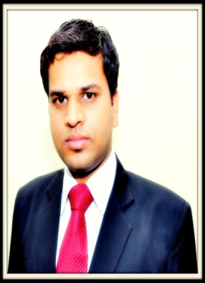

**ANIL KUMAR SHARMA**

H.No. 17 - K, Pocket 4, Mig Complex

Mayur Vihar Phase 3, Delhi - 110096

Mobile No.- 9999639688,9891511662

Email id:- anilsharma.sharma037@gmail.com

**Career Objective:-** Looking for a challenging growth-oriented position in banking sector, in a professionally managed organization, giving strong emphasis on setting high standards and enhancement of professional skillls of its people.

**Work Experience:- June. 10, 2013 to Oct.26.2014**

Working as a **Relationship Officer** with **IndusInd Bank Ltd**. , Greater Noida.

**Responsibilities:-**

* Responsible for generate the business through **'CASA' 'LI' 'GI' 'MF' 'FD'.**
* To maintain quality norms on depletion and cheque bouncing cases.
* To achieve the set productivity norms for banking.
* Always involved in different activities like arrange the presentaitons,'KNOP' and festive programs.
* To create new appointment to run our Branch.
* Responsible to direct sales of Banking products.
* Managing the corporate promo activities for increase the sales.

**Work Experience:- Oct. 28, 2014 to till date**

Working as a **Assistant Financial Service Manager** with **ICICI Prudential ltd.** Noida.

**Responsibilities:-**

Responsible for generate the business through **'LI'.**

* Managing the corporate promo activities for increase the sales.
* Always involved in different activities like arrange the presentations. KNOP and festive programs.

**Professional Qualification:-**

**PGDM (Marketing & Finance) from Accman Institute Of Management. (Greater Noida)**

**Summer Internship Programme (MAY-JUN 2012)**

**Apex Financial Solution, New Delhi.**

**Project Title:-** Financial and lifecycle analysis of banking asset an mortgage products.

**Academic Qualification:-**

* Passed 10th in 2003 from JSEB (Jharkhand)
* Passed 12th in 2005 from JAC (Jharkhand)
* Passed Graduation (B.Com Hon.) in 2009 from Ranchi University.

**Technical Qualification:-**

* Certificate Course in **Hindi & English Typing** from Kamla Commercial Institute, Jharkhand.
* Diploma course in **Computer.** (MS-Word, MS Excel, Powerpoint, Internet, Tally)

**Extra-Curricular Activities:-**

* All India Student Organization Member.
* National Cadet Corps Member.
* Banking Product Training Certificate given by **TrainBrain**.

**Interests And Hobbies:-**

* Internet Surfing, Making Friend, Travelling, PC games.

**Personal Details:-**

* Date of Birth : 22/03/1988
* Marital Status : Single
* Father’s Name : Mr. Subhag Sharma
* Permanent Address : H.No. 98,Chandani Chowk Obariya Road.D-Ranchi.
* Strengths : Confident, Positive Attitude, Hard worker.

**Place:- Delhi.**

**Date: (Anil Kumar Sharma)**